**APPLICATION USING TCP SOCKETS**

1. **ECHO CLIENT AND ECHO SERVER**

EX.NO. : 312217205003

DATE : P.G.ABINAYA

PROGRAM:

**tcpechoserver1.java**

import java.util.*;

import java.io.*;

import java.lang.*;

import java.net.*;

class tcpechoserver1

{

public static void main(String args[]) throws IOException

{

ServerSocket s = new ServerSocket(156);

Socket obj = s.accept();

DataInputStream din = new DataInputStream(obj.getInputStream());

DataOutputStream dout = new DataOutputStream(obj.getOutputStream());

System.out.println("Server is Running...");

String str=din.readLine();

System.out.println("Client: " + str);

dout.writeBytes(str+"\n");

}

}

**tcpechoclient1.java**

import java.util.*;

import java.io.*;

import java.lang.*;

import java.net.*;

class tcpechoclient1

{

public static void main(String args[]) throws IOException

{

BufferedReader in = new BufferedReader(new InputStreamReader(System.in));

Socket sc = new Socket("127.0.0.1",156);

DataInputStream din = new DataInputStream(sc.getInputStream());

DataOutputStream dout = new DataOutputStream(sc.getOutputStream());

System.out.println("Client is Running... Type 'BYE' to Quit");

System.out.print("Client: ");

Scanner a=new Scanner(System.in);

String str=a.nextLine();

dout.writeBytes(str+"\n");

String str2=din.readLine();

System.out.println("Server: " + str2);

}

}

**SAMPLE INPUT/OUTPUT:**

**tcpechoserver1.java**

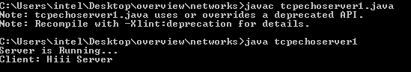

**tcpechoclient1.java**

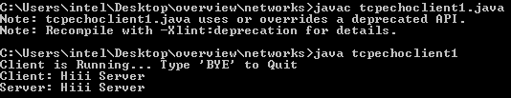

**APPLICATION USING TCP SOCKETS**

1. **CHAT**

EX.NO. : 312217205003

DATE : P.G.ABINAYA

PROGRAM:

**tcpchatserver.java**

import java.util.*;

import java.io.*;

import java.lang.*;

import java.net.*;

class tcpchatserver

{

public static void main(String args[]) throws IOException

{

ServerSocket s = new ServerSocket(1506);

Socket obj = s.accept();

DataInputStream din = new DataInputStream(obj.getInputStream());

DataOutputStream dout = new DataOutputStream(obj.getOutputStream());

System.out.println("Server is Running...");

while(true)

{

String str=din.readLine();

if(str.equals("BYE"))

{

System.out.println("Terminated...");

break;

}

System.out.println("Client: " + str);

System.out.print("Server: ");

Scanner a=new Scanner(System.in);

String str1=a.nextLine();

dout.writeBytes(str1+"\n");

}

}

}

**tcpchatclient.java**

import java.util.*;

import java.io.*;

import java.lang.*;

import java.net.*;

class tcpchatclient

{

public static void main(String args[]) throws IOException

{

BufferedReader in = new BufferedReader(new InputStreamReader(System.in));

Socket sc = new Socket("127.0.0.1",1506);

DataInputStream din = new DataInputStream(sc.getInputStream());

DataOutputStream dout = new DataOutputStream(sc.getOutputStream());

System.out.println("Client is Running... Type 'BYE' to Quit");

while(true)

{

System.out.print("Client: ");

Scanner a=new Scanner(System.in);

String str=a.nextLine();

if(str.equals("BYE"))

{

System.out.println("Terminated...");

dout.writeBytes(str+"\n");

break;

}

dout.writeBytes(str+"\n");

String str2=din.readLine();

System.out.println("Server: " + str2);

}

}

}

**SAMPLE INPUT\OUTPUT:**

**tcpchatserver.java**

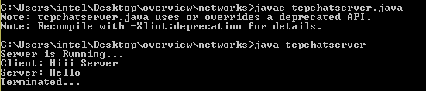

**tcpchatclient.java**

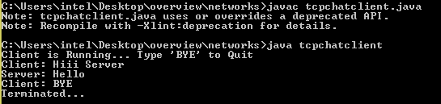

**APPLICATION USING TCP SOCKETS**

1. **FILE TRANSFER**

EX.NO. : 312217205003

DATE : P.G.ABINAYA

**PROGRAM:**

**tcpserverfile.java**

import java.util.*;

import java.io.*;

import java.lang.*;

import java.net.*;

class tcpserverfile {

public static void main(String[] args) throws Exception

{

try{

ServerSocket s = new ServerSocket(1566);

Socket obj = s.accept();

System.out.println("Enter the filename having content");

Scanner a=new Scanner(System.in);

String b=a.nextLine();

File vv= new File(b);

FileReader fr1=new FileReader(vv);

boolean exists = vv.exists();

BufferedReader br1=new BufferedReader(fr1);

DataInputStream din = new DataInputStream(obj.getInputStream());

DataOutputStream dout = new DataOutputStream(obj.getOutputStream());

String cd;

dout.writeBytes(exists+"\n");

if(exists==true)

{

while((cd=br1.readLine())!=null)

{

dout.writeBytes(cd+"\n");

System.out.println("The Contents in the File :"+cd);

}

String x=din.readLine();

System.out.println("File Contents Copied");

fr1.close();

br1.close();

obj.close();

}

}

catch(Exception e)

{

System.out.println("File not exists");

}

}

}

**tcpclientfile.java**

import java.util.*;

import java.io.*;

import java.lang.*;

import java.net.*;

class tcpclientfile {

public static void main(String[] args) throws Exception

{

try{

BufferedReader in = new BufferedReader(new InputStreamReader(System.in));

Socket sc = new Socket("127.0.0.1",1566);

DataInputStream din = new DataInputStream(sc.getInputStream());

DataOutputStream dout = new DataOutputStream(sc.getOutputStream());

String vv=din.readLine();

System.out.println("Enter the filename to be copied");

Scanner a=new Scanner(System.in);

String b=a.nextLine();

File zz= new File(b);

FileWriter fw2 = new FileWriter(zz);

String gg=din.readLine();

fw2.write(gg+'\n');

//System.out.println(gg);

if(vv.equals(true))

{

dout.writeBytes(gg+"\n");

sc.close();

fw2.close();

}

else

{

sc.close();

fw2.close();

}

}

catch(Exception e)

{

System.out.println("File Error");

}

}

}

**SAMPLE INPUT\OUTPUT:**

**tcpfileserver.java**

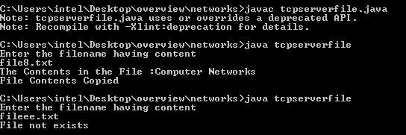

**tcpfileclient.java**

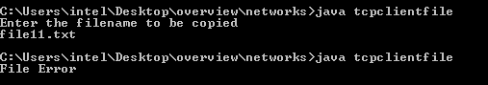

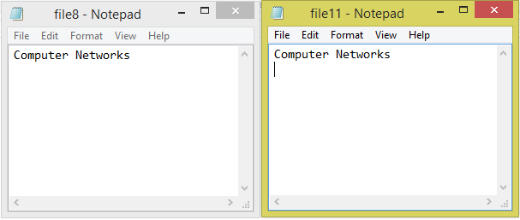

**APPLICATION USING UDP SOCKETS**

1. **ECHO CLIENT AND ECHO SERVER**

EX.NO. : 312217205003

DATE : P.G.ABINAYA

PROGRAM:

**UDPServer.java**

import java.io.*;

import java.net.*;

class UDPServer{

public static void main(String args[]) throws Exception {

DatagramSocket serverSocket = new DatagramSocket(9876);

byte[] receiveData = new byte[1024];

byte[] sendData = new byte[1024];

do{

DatagramPacket receivePacket = new DatagramPacket(receiveData, receiveData.length);

serverSocket.receive(receivePacket);

String sentence = new String( receivePacket.getData());

System.out.println("Client: " + sentence);

InetAddress IPAddress = receivePacket.getAddress();

int port = receivePacket.getPort();

String capitalizedSentence = sentence.toUpperCase();

sendData = capitalizedSentence.getBytes();

DatagramPacket sendPacket = new DatagramPacket(sendData, sendData.length, IPAddress, port);

serverSocket.send(sendPacket);

}while(false);

}

}

**UDPClient.java**

import java.io.*;

import java.net.*;

class UDPClient{

public static void main(String args[]) throws Exception {

System.out.print("Client: ") ;

BufferedReader inFromUser =new BufferedReader(new InputStreamReader(System.in));

DatagramSocket clientSocket = new DatagramSocket();

InetAddress IPAddress = InetAddress.getByName("localhost");

byte[] sendData = new byte[1024];

byte[] receiveData = new byte[1024];

String sentence = inFromUser.readLine();

sendData = sentence.getBytes();

DatagramPacket sendPacket = new DatagramPacket(sendData, sendData.length, IPAddress, 9876);

clientSocket.send(sendPacket);

DatagramPacket receivePacket = new DatagramPacket(receiveData,receiveData.length);

clientSocket.receive(receivePacket);

String modifiedSentence = new String(receivePacket.getData());

System.out.println("FROM SERVER:" + modifiedSentence);

clientSocket.close();

}

}

**SAMPLE INPUT\OUTPUT:**

**UDPServer.java**

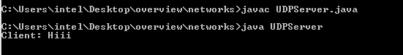

**UDPClient.java**

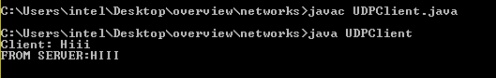

**APPLICATION USING UDP SOCKETS**

1. **CHAT**

EX.NO. : 312217205003

DATE : P.G.ABINAYA

PROGRAM:

**udpchatserver.java**

import java.io.*;

import java.net.*;

class udpchatserver

{

public static void main(String[] a) throws IOException

{

byte buf[] = new byte[1024];

int cport = 789,sport=790;

DatagramSocket serversocket = new DatagramSocket(sport);

DatagramPacket dp = new DatagramPacket(buf,buf.length);

BufferedReader dis = new BufferedReader(new InputStreamReader(System.in));

InetAddress ia = InetAddress.getLocalHost();

System.out.println("Server is Running...");

while(true)

{

serversocket.receive(dp);

String str = new String(dp.getData(), 0,dp.getLength());

if(str.equals("BYE"))

{

System.out.println("Terminated...");

break;

}

System.out.println("Client: " + str);

System.out.print("Server: ");

String str1 = new String(dis.readLine());

buf = str1.getBytes();

serversocket.send(new DatagramPacket(buf,str1.length(), ia, cport));

}

}

}

**udpchatclient.java**

import java.io.*;

import java.net.*;

class udpchatclient

{

public static void main(String[] a) throws IOException

{

byte buf[] = new byte[1024];

int cport = 789, sport = 790;

DatagramSocket clientsocket = new DatagramSocket(cport);

DatagramPacket dp = new DatagramPacket(buf, buf.length);

BufferedReader dis = new BufferedReader(new

InputStreamReader(System.in));

InetAddress ia = InetAddress.getLocalHost();

System.out.println("Client is Running... Type 'BYE' to Quit");

while(true)

{

System.out.print("Client: ");

String str = new String(dis.readLine());

buf = str.getBytes();

if(str.equals("BYE"))

{

System.out.println("Terminated...");

clientsocket.send(new DatagramPacket(buf,str.length(), ia,sport));

break;

}

clientsocket.send(new DatagramPacket(buf, str.length(), ia, sport));

clientsocket.receive(dp);

String str2 = new String(dp.getData(), 0,

dp.getLength());

System.out.println("Server: " + str2);

}

}

}

**SAMPLE INPUT\OUTPUT:**

**udpchatserver.java**

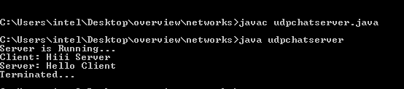

**udpchatclient.java**

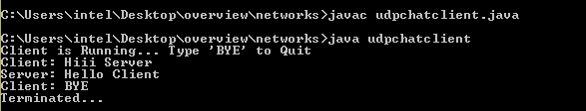

**APPLICATION USING UDP SOCKETS**

1. **FILE TRANSFER**

EX.NO. : 312217205003

DATE : P.G.ABINAYA

**PROGRAM:**

**serverfile.java**

import java.net.*;

import java.io.*;

import java.util.*;

public class serverfile

{

public static void main(String args[])throws IOException

{

try{

byte b[]=new byte[3072];

DatagramSocket dsoc=new DatagramSocket(2000);

System.out.println("Enter the filename to be copied");

Scanner a=new Scanner(System.in);

String e=a.nextLine();

File x=new File(e);

FileOutputStream f=new FileOutputStream(x);

DatagramPacket dp=new DatagramPacket(b,b.length);

dsoc.receive(dp);

String str=(new String(dp.getData(),0,dp.getLength()));

if(!str.equals(""))

{

System.out.println("The content in the file is:"+str);

f.write(dp.getData());

f.close();

System.out.println("File Content Copied");

}

else

{

f.close();

System.out.println("File not exists in client side");

}

}

catch(Exception e)

{

System.out.println("File Error");

}

}

}

**clientfile.java**

import java.net.*;

import java.io.*;

import java.util.*;

public class clientfile

{

public static void main(String args[])throws Exception

{

try{

int s=0;

byte b[]=new byte[1024];

byte x[]=new byte[1024];

String aa;

System.out.println("Enter the filename having the content");

Scanner a=new Scanner(System.in);

String e=a.nextLine();

File ff=new File(e);

if(!ff.isFile())

{

b=null;

String bb="a";

b=bb.getBytes();

DatagramSocket dsoc=new DatagramSocket(1000);

dsoc.send(new DatagramPacket(b,0,InetAddress.getLocalHost(),2000));

}

FileInputStream f=new FileInputStream(ff);

DatagramSocket dsoc=new DatagramSocket(1000);

if(ff.isFile())

{

int i=0;

while(f.available()!=0)

{

s=f.read();

b[i]=(byte)s;

i++;

}

f.close();

dsoc.send(new DatagramPacket(b,i,InetAddress.getLocalHost(),2000));

}

}

catch(Exception e)

{

System.out.println("File not exists");

}

}

}

**SAMPLE INPUT/OUTPUT**

**serverfile.java**

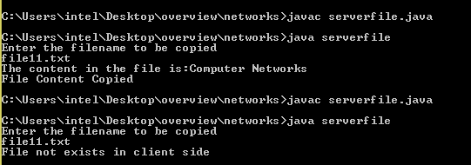

**clientfile.java**



